FCC regulation Title 47 Section 73 subsection 150 provides the expression that is to be used to calculate the potential signal strength of a given transmitter of a radio tower array.

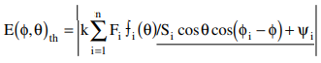

Where the **Energy** of a tower that is **PHI degrees from true north** and has **an angle of THETA degrees to the transmitter from the ground at 1km away** is equal to **the absolute value** of **the nominal station power as provided in Section 73 subsection 14**, times **the sum of the field ratio of the tower in question** times **the tower in question’s *antenna’s* radiation pattern** times…